To do by everyone:
Details
- Add your email, full affiliation and ORCID at the top of the document
Abstract
- Writing of abstract: to be decided
Title
- If you have suggestions feel free to add them below in a comment
M&m
- Litter classification overview: complete table for PP vs. Ospar and J-list classifications. If kept, still to be added to discussion part
- Decide which figures stay in the manuscript and which ones go to SI -> if we focus on policy, maybe better if we keep the SUP figures? if not with policy angle, other figures?
- “Microplastics and Mesoplastics Sampling” to be decided if those results should be included or not.
- DOI reference for the data analysis repository on GitHub -> open once minor revisions, adapt comment/research questions in the code so it matches the paper
Results
- All figures:
  - Please avoid titles in plots
- Under ‘Sampling Effort’:
  - Check exact % validated for Italy in 2023 (should be around 85-90%, lowest validation rate of the countries with high % validation rates)
- Fig. 3:
  - Fig. 3: adapt the plot, should be ‘absolute frequency’ rather than ‘abundance’. Idem for fig. 4. -> density, but make sure its very well defined beforehand, so there its clear
  - Is it 2021-2024 or 2022-2024? Data paper from Charlotte says 2022? 2022
  - For the discussion of figure 3: fill out the n = X, mean + se, mean > X. Would recommend rounding to one decimal place for both mean and se.
  - Begin year considered in the analysis in the figure title (202X), etc. The same for fig. 4, 5, 6, 7, 8, 10, 11 table 2, etc.
- Fig. 6:
  - Interpretation: verify whether correct
- Fig. 7:
  - Add betadisper analysis outcomes for the overall analysis (I could only find the results for the SUP dataset)
- Fig. 8 and 9
  - fill out the n = X, mean + se, mean > X. Would recommend rounding to one decimal place for both mean and se.
- Fig. 12
  - Change axis name as was done for fig. 3 -> absolute frequency
- Fig. 13
  - For some years, the bars close to 0 are very hard to see, could we make use of e.g. a broken y-axis to make these parts of the y-axis more visible?
  - Fill out ‘Belgium, Greece, Hungary, and Latvia consistently showed low floating macrolitter densities (< X items m⁻¹ h⁻¹) with minimal variation’. -> relative abundance
Discussion
- Add relevant references where fitting
Acknowledgements
- Adapt/add where needed
Funding
- Adapt/add where needed
Authors’ contributions
- Fill out your contributions
Supplementary info
- Organise the SI & check which figures from the main document should go in here

Title: For example: Evaluating European Riverine Macrolitter via Youth Citizen Science: Transboundary Patterns, Local Drivers, and Policy Implications

^{X}Flanders Marine Institute (VLIZ), InnovOcean Campus, Jacobsenstraat 1, 8400 Ostend, Belgium
^{X}BETA Technological Center (BETA). University of Vic-Central University of Catalonia. Ctra de Roda 70, 08500 Vic, Barcelona, Catalonia, Spain
^{X}Department of Computer Engineering, Universidad de Burgos, Burgos, Avda. Cantabria S/N, 09006 Burgos, Spain
^{X} International Research Center in Critical Raw Materials for Advanced Industrial Technologies (ICCRAM), Universidad de Burgos, Centro de I+D+I. Plaza Misael Bañuelos, s/n, 09001, Burgos, Spain.
^{X}XXX
^{X}XXX

List of contributors, order to be confirmed [Name, email, affiliation, ORCID]
- VLIZ: Flanders Marine Institute (VLIZ), InnovOcean Campus, Jacobsenstraat 1, 8400 Ostend, Belgium
  - Nelle Meyers (nelle.meyers@vliz.be; https://orcid.org/0000-0001-9205-6260)
  - Line Debaveye (XXX)
  - Charlotte Dhondt (XXX)
  - Therese Nitschke (XXX)
  - Lisa Devriese (XXX)
  - Gert Everaert (XXX)
  - Jan Seys (XXX)
  - Ana Isabel Catarino, https://orcid.org/0000-0002-8796-0869

- BETA Technological Center (BETA). University of Vic-Central University of Catalonia. Ctra de Roda 70, 08500 Vic (Barcelona, Catalonia, Spain).
  - Meritxell Abril (https://orcid.org/0000-0002-5103-5567)
  - Maria Soria (http://orcid.org/0000-0001-9379-7626)
  - Julio López-Doval (http://orcid.org/0000-0002-0090-8532)
  - Lorenzo Proia (http://orcid.org/0000-0002-7212-7698)

- University of Burgos (UBU).
  - Antonio Canepa-Oneto (https://orcid.org/0000-0002-0608-2743)
  - Patricia De La Fuente Gamero (https://orcid.org/0000-0002-6048-1534)

- Plastic Pirates – All contributors: Tim Kiessling, DLR Team, all participant institutions

Journal suggestions
- Microplastics and Nanoplastics: IF/NA https://microplastics.springeropen.com/ (Full open access – APC €1240.00) – guidelines: https://link.springer.com/journal/43591/submission-guidelines/research à Special issue?

Abstract
XXX

List of abbreviations
Abbreviation | Meaning
ATR-FTIR | Attenuated Total Reflectance Fourier-Transform Infrared
DRS | Deposit Return Schemes
EPR | Extended producer responsibility
EPS | Expanded polystyrene
GES | Good Environmental Status
IQR | Interquartile range
JRC | Joint Research Centre
MDG | Mean decrease in Gini index
MSFD | Marine Strategy Framework Directive
OOB | Out-of-bag
PERMANOVA | Permutational multivariate analysis of variance
PPWR | Packaging and Packaging Waste Regulation
RF | Random forest
s.e. | Standard error
SUP | Single-use plastic
SUPD | Single-Use Plastics Directive
UWWTD | Urban Wastewater Treatment Directive
WFD | Water Framework Directive
ZPAP | EU Zero Pollution Action Plan

Introduction
Plastic pollution is a major environmental concern, ubiquitous across aquatic ecosystems, with rivers acting as primary conduits transporting land-based macrolitter towards the oceans (Bruge et al., 2018; Dittmann et al., 2025; Van Emmerik et al., 2020). Establishing robust monitoring data on riverine litter composition and transport dynamics is essential to identify land-based pollution sources, guide targeted mitigation strategies, and evaluate the real-world effectiveness of environmental policies. Yet, conventional monitoring approaches often rely on localised field surveys that are resource-intensive as well as geographically constrained, which limits their capacity to capture the high spatial and temporal variability of riverine litter dynamics (Dittmann et al., 2025).

In this context, citizen science has emerged as a validated and scalable approach that complements traditional monitoring by broadening geographical reach, increasing sampling frequency and expanding data collection capacity (Dittmann et al., 2023 & 2025; Kiessling et al., 2023). When supported by standardised sampling protocols and multi-step data verification pipelines, such as metadata screening, photographic validation, and expert confirmation, participatory monitoring can generate scientifically reliable data that allows to identify pollution accumulation hotspots, evaluate riverine transport mechanisms, and inform evidence-based environmental policy Dittmann et al., 2023 & 2025; Kiessling et al., 2023).

A prominent example of this citizen science approach is the 'Plastic Pirates – Go Europe!' initiative, which engages schoolchildren and youth groups in collecting standardised data on riverbank and surface-floating macrolitter, and on riverine micro- and mesoplastics (Kiessling et al., 2022). Over the past decade, several European countries have implemented the Plastic Pirates framework which resulted in valuable scientific findings that contributed to a better understanding of riverine litter abundance, composition and spatial distribution at the national level (Dittmann et al. 2023 & 2025). In Germany, seven years of national assessments enabled the establishment of long-term riverbank litter baselines (median 0.28 items/m²), identified key hotspots of floating macro- and microplastics, evaluated the potential effectiveness of single-use plastic (SUP) restrictions, and demonstrated that youth-generated data can match professional standards and generate policy-relevant evidence that advances the European Union’s zero pollution and sustainability goals (Dittmann et al., 2023, 2024 & 2025; Kiessling et al., 2021). Similar national campaigns across European rivers, e.g. in Lithuania, have further confirmed the capacity of citizen scientists to map local litter drivers and SUP prevalence (Uogintė et al., 2024). However, despite these valuable national achievements, existing studies remain geographically fragmented. To date, no harmonised, pan-European analysis of the Plastic Pirates dataset has evaluated riverine macrolitter composition and floating transport across multiple European countries simultaneously, leaving a major gap in our understanding of transboundary litter patterns.

To address this knowledge gap, this study presents the first harmonised pan-European assessment of riverine macrolitter based on the Plastic Pirates datasets collected between 2021 and 2024 across rivers in 13 European countries (Austria, Belgium, Bulgaria, Germany, Greece, Hungary, Italy, Latvia, Lithuania, Portugal, Spain and Slovenia). Specifically, this study aimed to:

1. Quantify and compare riverbank macrolitter abundance and composition across European countries to determine whether riverine litter shares a common European pollution fingerprint or exhibits distinct national patterns.

2. Assess the distribution of SUP across countries to investigate whether regulated plastic items show shared patterns or country-specific differences.

3. Examine surface-floating macrolitter to provide additional insights into litter transport dynamics across European rivers.

By examining both common European patterns and national differences in riverine litter pollution, this study provides empirical evidence to assess the alignment and real-world reach of key EU legislative frameworks, including the Single-Use Plastics Directive (Directive (EU) 2019/904), the Packaging and Packaging Waste Regulation (PPWR) and the EU Zero Pollution Action Plan (ZPAP) (Devriese et al., 2025; Van Leeuwen et al., 2023). Ultimately, the findings contribute to a better understanding of the extent to which plastic pollution requires coordinated, cross-border action or targeted national interventions to reduce plastic inputs from source to sea.

Material and Methods
2.1 Study Area
Data was collected within the Plastic Pirates – Go Europe! Project (Horizon Europe, 20xy-2025), supported in some cases by national or regional co-funding mechanisms, established in 13 European countries: Austria, Belgium, Bulgaria, Germany, Greece, Hungary, Italy, Latvia, Lithuania, Portugal, Spain and Slovenia (Fig. 1). Data used in this work were collected between 2021 and 2024, in inland waterbodies such as rivers, streams, canals, and other transitional or inland waterways, with most national projects contributing from 2022 onwards. Sampling effort varied across participating countries (Fig. 2), with various schools or youth groups participating according to their availability and recruitment success.
- 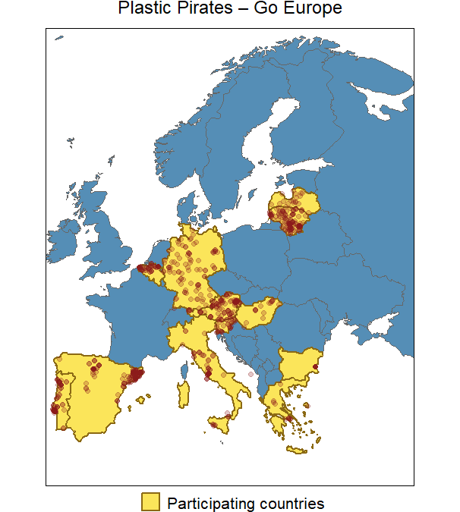
Fig. 1. Map of study area within European project Plastic Pirates – Go Europe! and scope of the presented study (2021-2024). Yellow countries indicate the participating countries to the Plastic Pirates – Go Europe! Initiative (Ecologic Institute (2020)). The red dots mark the sampling locations for macro- and microlitter, with deeper red areas indicating higher sampling intensity in that area.

Table 1: An overview of the litter classification categories and their corresponding conversions to the J-list (JRC) and OSPAR classification systems (REFs).
Litter classification categories
Plastic Pirates | J-list | OSPAR
Plastic
Plastic bags
Plastic bottles for drinks
Plastic lids of drink bottles
Takeaway and fast-food packaging, including disposable coffee cups and their lids
Plastic cutlery and plastic plates (also plastic coffee stirrers and plastic straws)
Plastic packaging for sweets, biscuits, crisps, etc.
Cotton buds with plastic sticks (Q-tips’)
Wet wipes, tampons and sanitary towels
Polystyrene [styrofoam]
Total number of single-use plastic
Small pieces of plastic less than 2.5 cm
Other unidentifiable plastic objects
Metal
Metal beverage cans
Bottle caps
Aluminium foil
Other unidentifiable metal objects
Glass
Glass bottles for drinks
Glass pieces
Other unidentifiable glass objects
Other waste
Cigarette butts
Paper
Textiles [clothing, shoes, textile remnants]
Rubber [car tyres, rubber bands]
Balloons
Other unidentifiable waste
Local waste
Total number (including single-use plastic)

2.2 Macrolitter Sampling
Macrolitter (> 25 mm (GESAMP (2019)) was observed and recorded in riverbanks, by each participating class or youth group, using three complementary approaches: river transects (checking litter abundance and category, Group A), systematic litter collection (checking litter diversity, Group B) and visual observation of floating litter (Group C) (Kiessling et al., 2022). For each approach, participants collected, categorised and documented the observed litter, following the standardised Plastic Pirates protocol (Kiessling et al., 2018). Documentation (photographs of litter items) and metadata (date, location, river name etc.) were submitted by each participating school class or youth group, compiled with the assistance of the supervising teacher, and sent for verification by experts from participating national institutions. Litter classification categories were recorded according to the standardised Plastic Pirates protocol (Kiessling et al., 2022), with subsequent mapping to the internationally recognised classification systems developed by the Joint Research Centre (JRC) (J-list) and the OSPAR classification system (Table 1) (REFs).

2.3 Microplastics and Mesoplastics Sampling
Floating microplastic particles (in this study, limited to 5 - 1 mm) and mesoplastic items (25 – 5 mm) were sampled with a manta net (opening 11 x 35 cm, mesh size 1 mm), which was deployed for around 60 min. at each sampling site. River flow velocity was estimated by assessing the time a stick would travel over a 20 m transect (in triplicate), as detailed in the Plastic Pirates protocol (Kiessling et al., 2022). In some cases, samples were dried and visually inspected for plastics by the citizen science participants. Selected samples were further processed by the national project coordinators or partners for polymer identification (Supplementary Information X).

2.4 Verification and Harmonisation of Data
Submitted datasets underwent a stepwise verification procedure, including metadata checks, plausibility screening and harmonisation following Kiessling et al. (2018). For microplastic samples, verification included polymer identification using Attenuated Total Reflectance Fourier-Transform Infrared (ATR-FTIR) analysis. Harmonisation across all national and local datasets enabled the publication of a Europe-wide dataset by Dhondt et al. (2025) and its first analysis in the present study.

2.5 Statistical/Data Analyses
All data was integrated into one harmonised dataset and analysed for: (i) prevalence and quantities of common litter categories per region, (ii) litter diversity across geographical contexts, (iii) comparison of floating versus riverbank items and (iv) links between observed patterns and existing environmental policies. We assessed the sampling effort (number of sampling campaigns and validated sampling points) of each participating country during the period between 2021-2024, as well as the number of sampled water bodies (rivers, streams, canals, etc) sampled (Fig. 2). Mean abundances (± standard error, s.e.) of each litter category were estimated for the entire validated dataset, as well as per participating country. Subsequently, a compositional dataset was constructed by expressing the relative contribution of each litter category as a proportion of the total items recorded within each country.

To investigate patterns of similarity among countries and litter categories, a heatmap coupled with hierarchical clustering was generated. Values were standardised across columns using z‑score scaling, to remove overall magnitude differences among countries and emphasise relative deviations in composition, thereby improving the detection of underlying compositional patterns. The generated heatmap encoded standardised values using a continuous colour gradient, facilitating the identification of relatively high and low contributions. A hierarchical clustering was applied to both rows and columns of the heatmap, grouping together countries with similar compositional profiles and litter categories that tended to co‑occur across countries (Fig. 6).

Differences in litter composition among countries were statistically assessed using a permutational multivariate analysis of variance (PERMANOVA) implemented through the function ‘adonis2’ in the vegan R package (Oksanen et al., 2025). Prior to the analysis, raw community data were standardised using the Hellinger transformation via the function ‘decostand’. This transformation, which involves scaling abundances by sample totals followed by a square‑root transformation, is widely recommended for community composition datasets because it reduces the dominance of highly abundant categories, mitigates issues related to double zeros, and preserves Euclidean properties. Based on the transformed data, a dissimilarity matrix was computed using Euclidean distance using the ‘vegdist’ function. The use of Euclidean distance on Hellinger‑transformed data is appropriate because it yields a meaningful representation of compositional differences in multivariate space while maintaining compatibility with linear ordination and variance‑partitioning techniques. A PERMANOVA was then applied to test for significant differences in multivariate composition among countries, using country identity as the main explanatory factor. Statistical significance was evaluated through 999 permutations, and the analysis employed marginal sums of squares to estimate the independent contribution of the factor. This non‑parametric approach provides a robust framework for assessing differences in community composition among groups without assuming multivariate normality, making it well suited to ecological and compositional datasets.

Following the identification of significant compositional differences among countries, the contribution of individual litter categories to these differences was further examined using a multivariate classification approach based on Random Forests (RFs). The analysis was conducted with the ‘randomForest’ R package (Liaw & Wiener, 2002) and applied to the Hellinger‑transformed dataset. The model was trained to predict country identity (categorical response) from the multivariate composition of litter categories. A total of 500 trees were grown, and variable‑importance metrics were computed during model training. Random Forests are particularly suitable in this context due to their ability to model complex, non‑linear relationships and interactions among variables without requiring parametric assumptions. Variable importance was evaluated using the Mean Decrease in Gini index (MDG), which quantifies the contribution of each variable to improving node purity across the ensemble of trees. Higher MDG values indicate that a variable contributes more strongly to discriminating among countries. Model performance was assessed using the confusion matrix and overall classification accuracy, while the out‑of‑bag (OOB) error rate served as an internal cross‑validation measure of predictive performance.

In addition, the same analytical procedures stated above were independently applied to the subset of litter categories classified as single‑use plastics (SUP). All the analysis were performed using the statistical programming language R version 4.5.3 (R Core Team, 2026).

Results
The code used for statistical analyses and figure generation is openly available on GitHub and archived on Zenodo ([DOI: https://github.com/ajcanepa/Plastic_Pirates_EU]).

Macrolitter
Sampling Effort
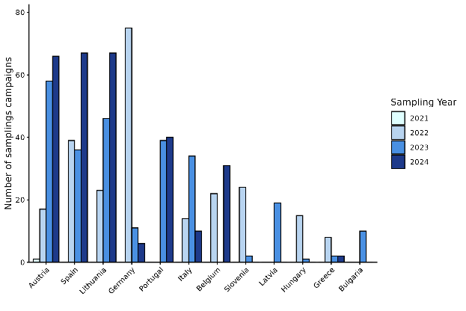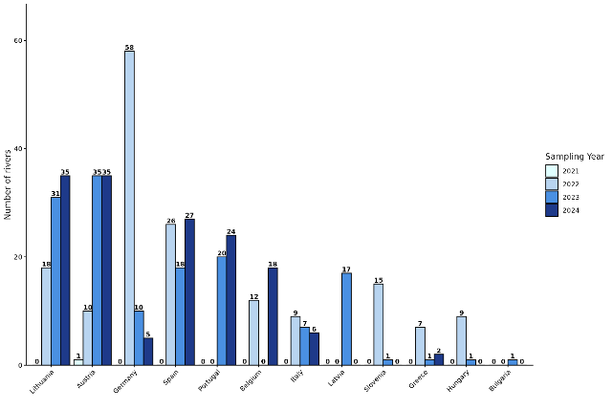
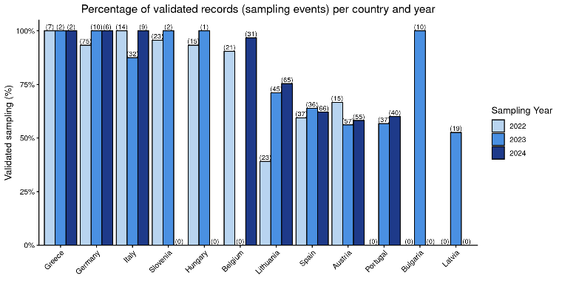
Fig. 2 A, B and C. Yearly distribution of number of riverine sampling campaigns (A), the number of rivers covered (B) per participating country in the initiative Plastic Pirates – Go Europe!, as well as the percentage of validated records (sampling events) (C) per country per year, between 2022-2024.

Austria, Spain, Lithuania, and Germany contributed the largest overall sampling efforts. Germany recorded the highest number of sampled waterbodies in 2022, covering 58 rivers across 75 sampling campaigns (Fig. 2A and B). In 2023 and 2024, Lithuania and Austria each sampled more than 30 waterbodies, within 45 and 65 campaigns, respectively. Spain and Portugal followed in 2024, sampling 27 and 24 rivers through 40 and 65 campaigns, respectively.

Across nearly all countries and years, at least 50% of sampling events were either validated or reported no issues following validation (see Fig. 2C and ‘2.4 Verification and harmonisation of data’). Validation rates exceeded 85/90 %? in Greece, Germany, Italy, Slovenia, Hungary, Belgium, and Bulgaria, where nearly all submitted sampling events were either validated or reported no issues. In the remaining countries, these rates generally ranged between 50% and 75%.

Observed Litter Patterns

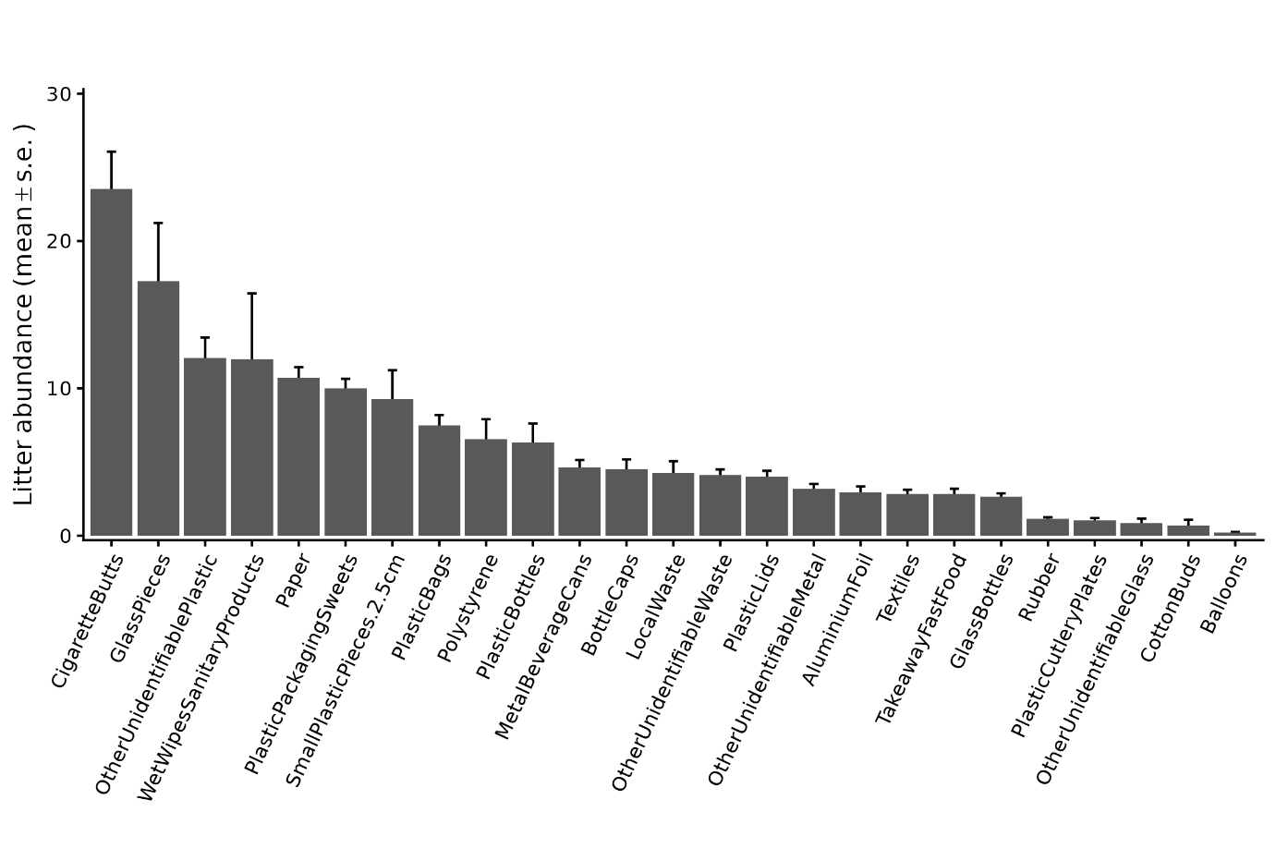
Fig. 3. Total mean litter absolute frequency ± s.e per litter category, observed between 2021-2024, in Austria, Belgium, Bulgaria, Germany, Greece, Hungary, Italy, Latvia, Lithuania, Portugal, Slovenia and Spain.

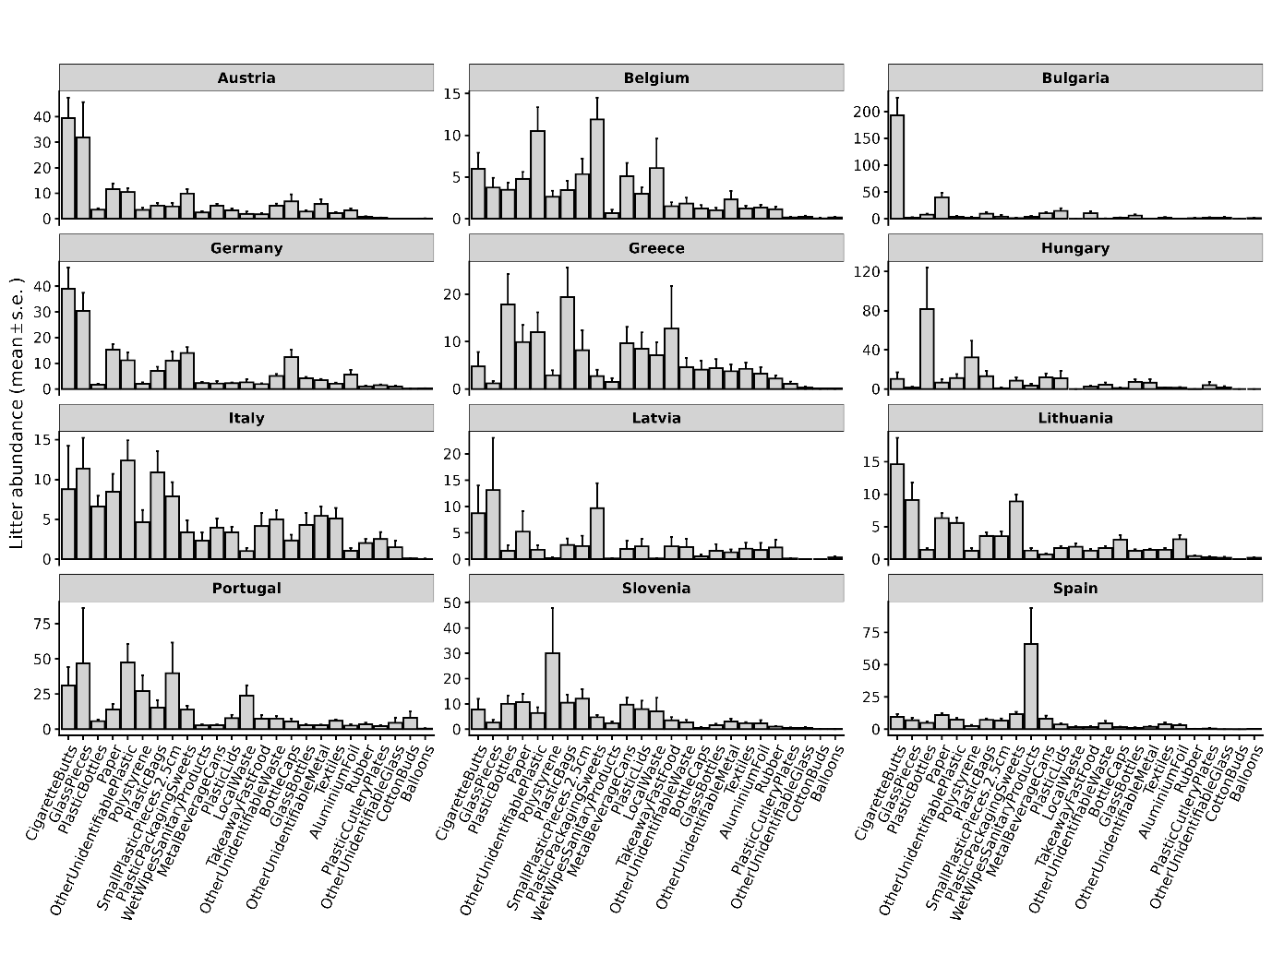
Fig. 4. Litter mean absolute frequency per category ± s.e., observed between 202X -2024, per participating country.

For the entire validated dataset, ‘CigaretteButts’ were the most abundant litter category (with a mean ± s.e. of 23.5 ± 2.5, n = X) (Fig. 3), followed by ‘GlassPieces’ (17.3 ± 3.9, n = X) (Fig. X). ‘OtherUnidentifiablePlastic’ (12.1 ± 1.37, n = X) and ‘WetWipesSanitaryProducts’ (12.0 ± 4.5, n = X) ranked next among the most common categories. The relative distribution of litter categories revealed both widespread pan-European patterns and geographical variation in litter composition (Fig. 4). ‘CigaretteButts’ were the most abundant category overall (23.5 ± 2.5, n = X) and featured prominently in observations from Bulgaria (mean +- se, n = X), Austria (mean +- se, n = X), Germany (mean +- se, n = X), and Lithuania (mean +- se, n = X). ‘GlassPieces’ were also consistently well represented across sampling sites in Austria (mean +- se, n = X), Germany (mean +- se, n = X) (mean +- se, n = X), Italy (mean +- se, n = X), Portugal (mean +- se, n = X), and Lithuania (mean +- se, n = X). Other notable patterns included a relatively high representation of ‘PlasticBottles’ in observations from Hungary (mean +- se) and Greece (mean +- se), plastic bags in Greece (mean +- se), and ‘Polystyrene’ in Slovenia (mean +- se). ‘WetWipesSanitaryProducts’ showed particularly high mean absolute frequencies in observations from Spain (mean +- se), substantially exceeding those recorded elsewhere. In observations from Belgium, ‘PlasticPackagingSweets’ (mean +- se) and ‘OtherUnidentifiablePlastic’ (mean +- se) were among the most frequently recorded categories.

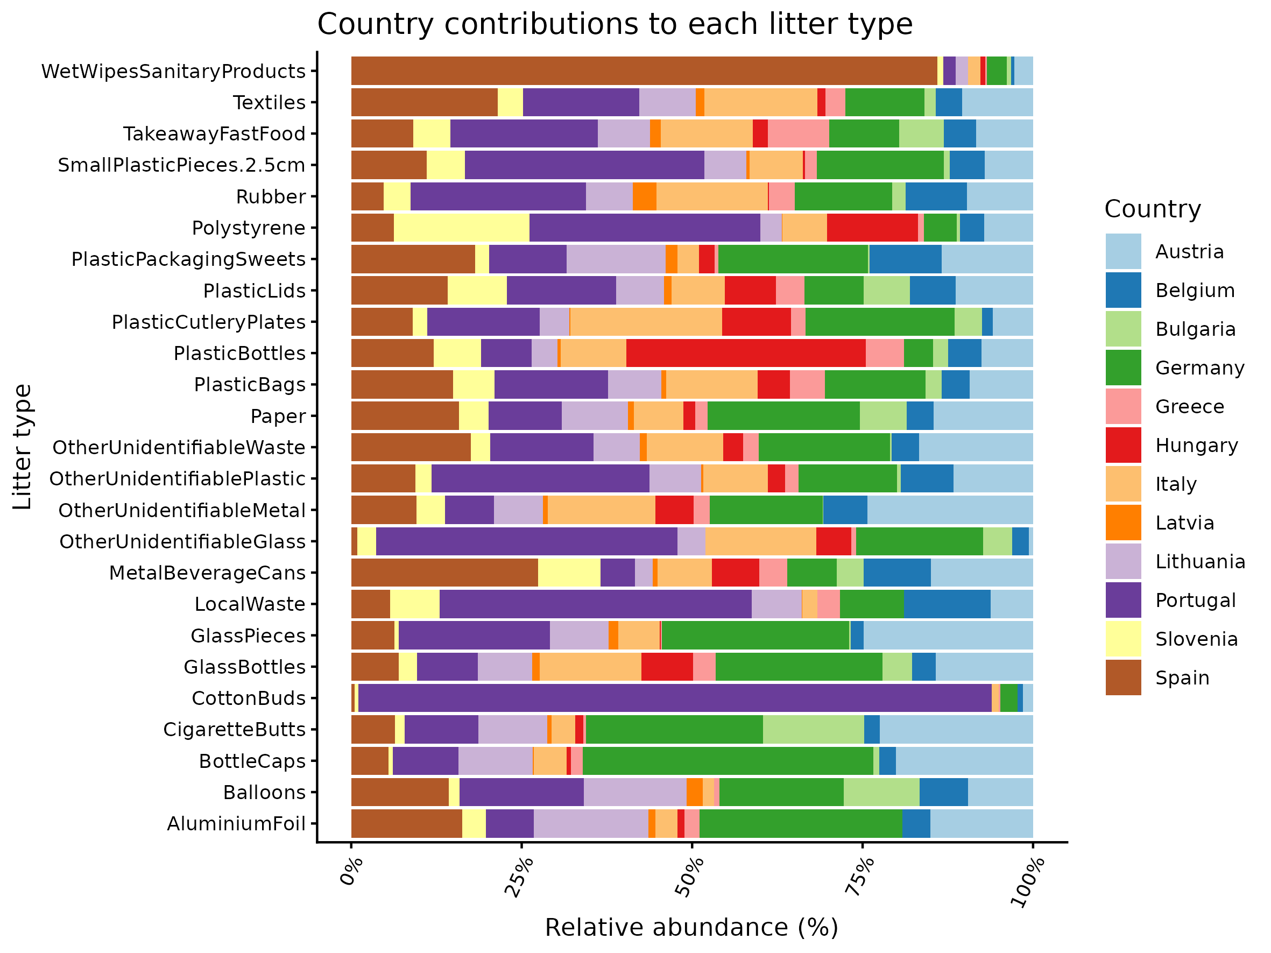
Fig. 5. Relative frequency of litter observations per category, observed between 202X -2024, per participating country.

When examining the relative frequency of litter observations across national datasets, most categories exhibited a widespread, balanced distribution across European observations, reflecting a broad pan-European baseline (Fig. 5). Categories such as ‘PlasticLids’, ‘Textiles’, ‘TakeawayFastFood’, and ‘PlasticPackagingSweets’ were recorded across almost all participating national datasets with comparable relative shares.

In contrast, a few specific litter categories displayed marked localised relative dominance in the dataset (Fig. 5). For example, over 75% of all European observations of ‘WetWipesSanitaryProducts’ were recorded in sampling locations in Spain, where ‘MetalBeverageCans’ also represented a notable relative share (> 25%). Similarly, ‘CottonBuds’ were predominantly recorded in observations from Portugal, alongside relatively higher proportions of ‘Polystyrene’, ‘OtherUnidentifiableGlass’, ‘LocalWaste’, and ‘SmallPlasticPieces.2.5cm’. Observations from Hungary accounted for the largest relative proportion of recorded items within ‘PlasticsBottles’. Overall, while observations in countries like Germany, Portugal, and Spain encompassed a wide variety of litter categories, observations in other national datasets (e.g., Hungary, Bulgaria, and Greece) were concentrated in a narrower set of categories.

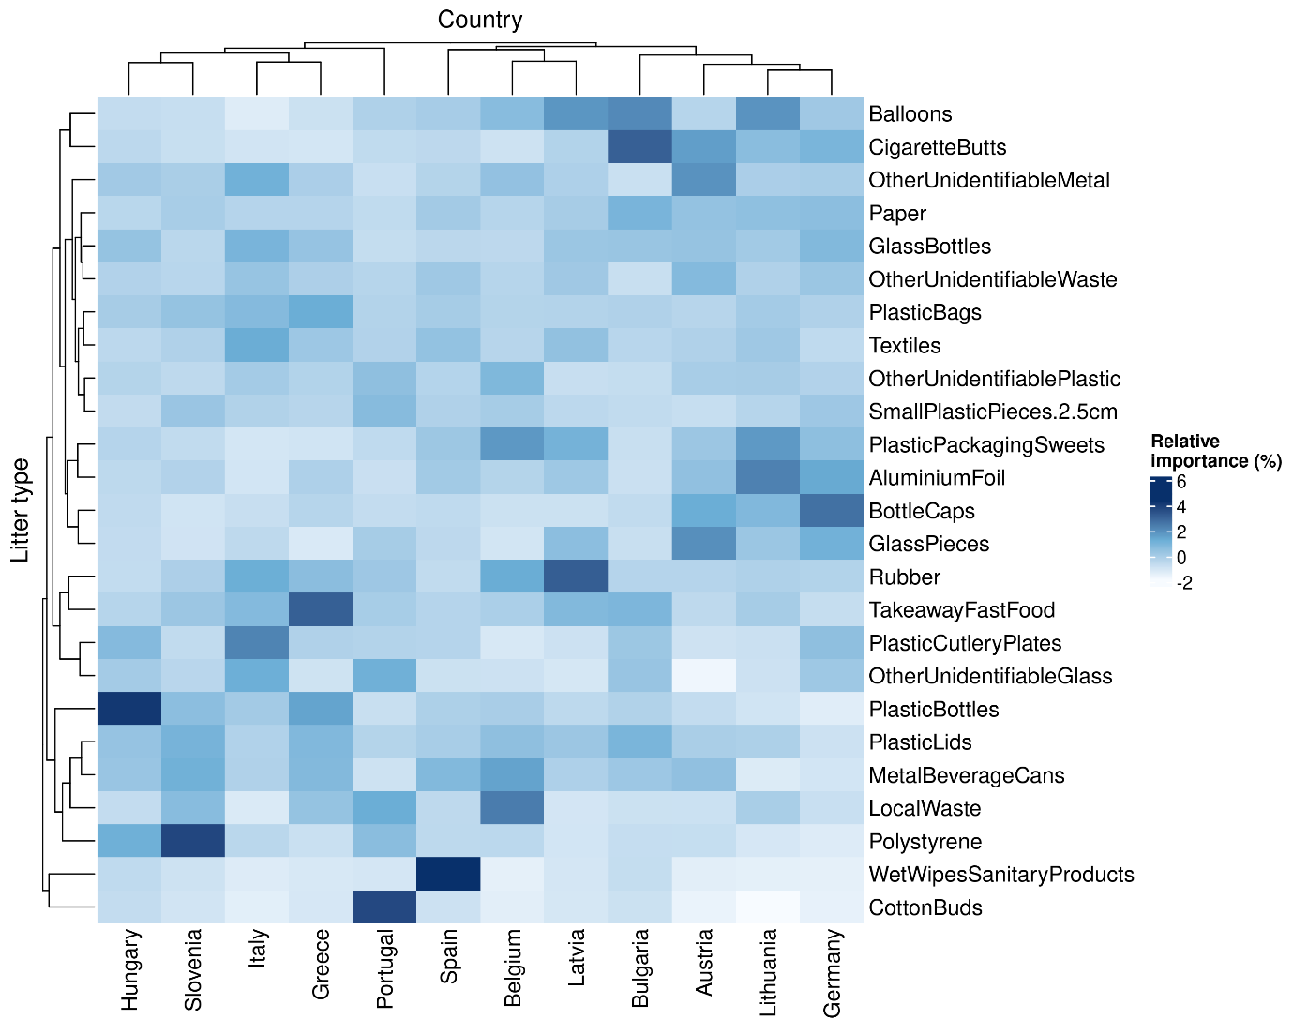
Fig. 6. Heatmap showing the standardised relative representation of litter categories across the 12 participating countries, observed between 2021 -2024, with hierarchical clustering applied to both countries (columns) and litter categories (rows). Z-score scaling highlights how the relative representation of each litter category varies between countries. The dendrograms group countries with similar litter-category profiles and categories with similar patterns across countries.

Overall, the heatmap in Fig. 6 reveals broadly similar litter-category profiles across countries, with many categories showing comparable relative importance across national datasets, as reflected by the widespread light-to-moderate blue shading. This suggests an overlap in litter composition across the studied areas, although several categories also exhibit pronounced country-specific deviations. Superimposed on the seemingly shared baseline, the hierarchical clustering of countries based on the relative importance of litter categories, validated by bootstrap resampling, revealed two primary geographical clusters. The first cluster comprised Spain, Belgium, Latvia, Bulgaria, Austria, Lithuania and Germany, while the second grouped. Hungary, Slovenia, Italy, Greece and Portugal.

Within the first cluster, two sub-groups were discernible. The first comprised Spain, Belgium and Latvia, characterised by relatively high contributions of ‘MetalBeverageCans’ in Belgium and Spain, and of ‘PlasticPackagingSweets’, ‘Rubber’ and ‘Balloons’ in Belgium and Latvia. The second included Germany, Italy, Austria and Lithuania, which showed comparatively higher relative contributions from small, fragmented items (‘AluminiumFoil’, ‘BottleCaps’ and ‘GlassPieces’), as well as ‘CigaretteBuds’, ‘Balloons’ and ‘PlasticPackagingSweets’. Within the second cluster, neighbouring countries Hungary and Slovenia grouped together, with relatively high contributions from ‘Polystyrene’, ‘MetalBeverageCans’ and ‘PlasticLids’. Italy and Greece also formed a sub-group, characterised by higher relative contributions from categories such as ‘TakeAwayFastFood’.

At the category level, hygiene-related litter items (‘WetWipesSanitaryProducts’ and ‘CottonBuds’) formed a distinct cluster in the row dendrogram. These items are largely driven by Spain and Portugal, resulting in a clear separation from other litter categories. This cluster does not align with the main country groupings but instead reflects a separate pattern present across both groups.

Table 2: PERMANOVA results (adonis2, 999 permutations) testing for differences in litter composition observed between 2021-2024 among countries based on the Bray–Curtis dissimilarity matrix, considering both the overall litter dataset and the subset of litter categories classified as single-use plastics (SUP).
Analysis | Term | df | Sum of squares (SS) | F | R² | p-value | Permutations
Overall analysis | Country | 11 | 27.724 | 5.3324 | 0.09814 | 0.001 | 999
Overall analysis | Residuals | 539 | 254.764 |  | 0.90186
Overall analysis | Total | 550 | 282.488 | 5.2616 | 1.000 | 0.001 | 999
Single-Use Plastics (SUP) | Country | 11 | 23.006 |  | 0.09697
Single-Use Plastics (SUP) | Residuals | 539 | 214.252 | 0 | 0.90303
Single-Use Plastics (SUP) | Total | 550 | 237.258 |  | 1

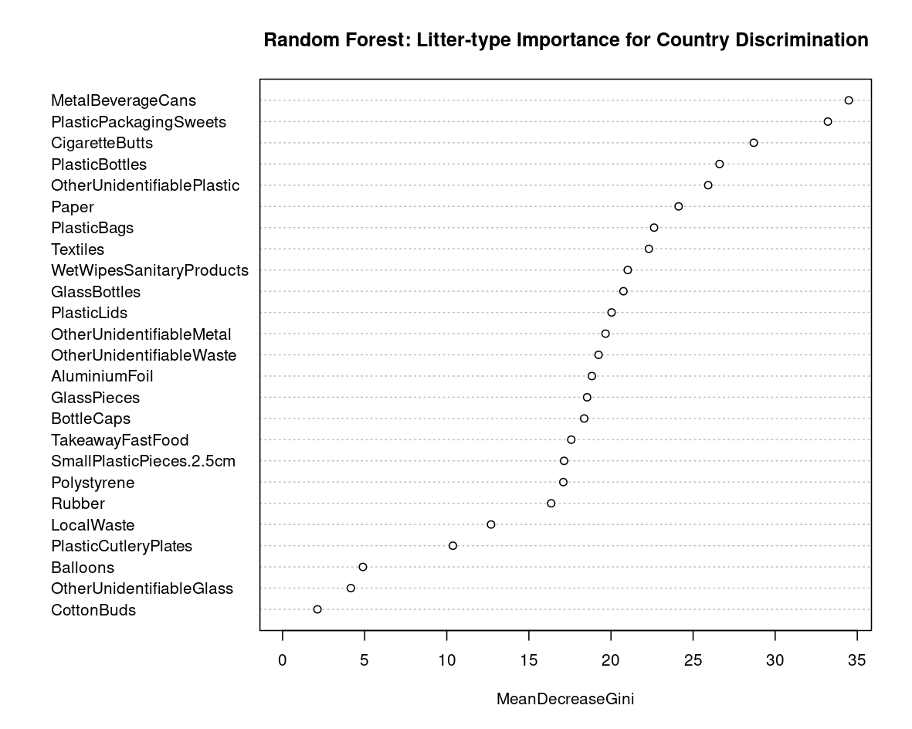
Fig. 7. Variable importance of litter categories observed between 2021 -2024 for discriminating among countries based on the multivariate random forest classification model, expressed as mean decrease in Gini index (MDG). Higher values indicate a greater contribution of a litter category to country classification, with the litter categories ‘MetalBeverageCans’ and ‘PlasticPackagingSweets’ showing the highest discriminatory importance.

Observed differences in litter composition among the countries were significant (PERMANOVA; adonis2, 999 permutations; F = 5.33, R² = 0.098, p = 0.001) (Table 2). However, the treatment “country” explained only a small proportion of the variation (9.8%), indicating that 90.2% of the observed variability is still driven by other factors. Multivariate RF classification further supported these findings, showing a poor predictive performance based on litter composition, with a high OOB error rate (62.43%; accuracy ≈ 38%) and substantial misclassification among most countries. Classification accuracy varied considerably, ranging from 90% for Bulgaria to 0% for Greece, reflecting the limited ability of litter composition to consistently distinguish between countries. This is also supported by the heatmap (Fig. 6), which revealed broadly similar litter-category profiles across countries, alongside geographical clustering and country-specific deviations.

Only a limited number of categories, particularly ‘MetalBeverageCans’ and ‘PlasticPackagingSweets’, followed by ‘CigaretteButts’, ‘PlasticBottles’ and ‘OtherUnidentifiablePlastic’, contributed substantially to country discrimination (Fig. 7). Most other categories had comparatively low importance values, consistent with the limited classification performance of the model (Supplementary Information X). Together, these findings indicate that, although litter composition differed significantly among countries, these differences were relatively subtle and driven by a limited subset of litter categories.

Single-Use Plastic Macrolitter
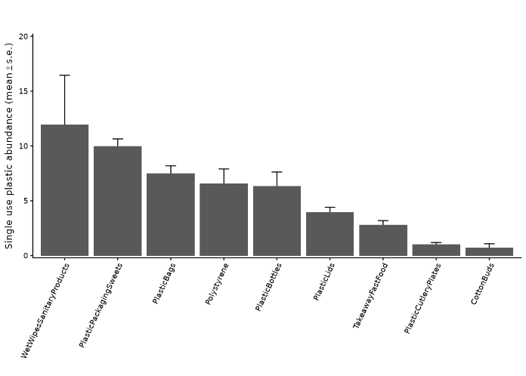
Fig. 8. Total mean litter absolute frequency ± s.e within the subset of litter categories classified as single-use plastics (SUP), observed between 2021-2024, in Austria, Belgium, Bulgaria, Germany, Greece, Hungary, Italy, Latvia, Lithuania, Portugal, Slovenia and Spain.

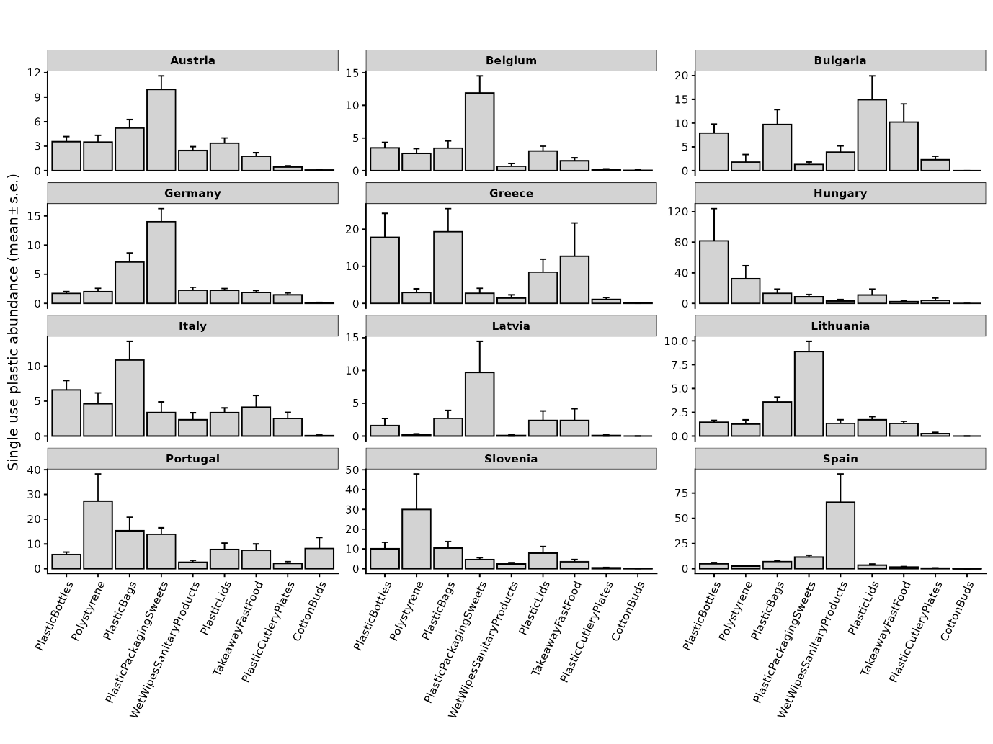
Fig. 9. Litter mean absolute frequency ± s.e. for the subset of litter categories classified as single-use plastics (SUP), observed between 2021 -2024, per participating country.

Single-use plastic litter categories accounted for 36 % (9 out of 25 categories) of the total litter categories identified across all observations (years and countries). When considering only SUP products, the litter category ‘WetWipesSanitaryProducts’ was the most frequently recorded across all years and countries (X ± SE) (Fig. 8), followed by ‘PlasticPackagingSweets’ (X ± SE) and ‘PlasticBags’ (X ± SE). The geographical distribution of these categories revealed distinct patterns (Fig. 9). ‘PlasticPackagingSweets’ was the most represented category in Austria, Germany, Belgium, Latvia and Lithuania, whereas hygiene-related litter (‘WetWipesSanitaryProducts’) showed a particularly high representation, driven mainly by observations from Spain. ‘PlasticBags’ showed relatively high representation in Italy (mean < x) and Greece (mean < x), while ‘Polystyrene’ was most represented in Portugal (mean < x) and Slovenia (mean < x). ‘PlasticBottles’ featured prominently in Hungary (mean < x) and Greece (mean < x), whereas in Bulgaria, ‘PlasticLids’ and ‘TakeAwayFastFood’ were the most frequently recorded SUP categories (mean < x and mean < x, respectively).

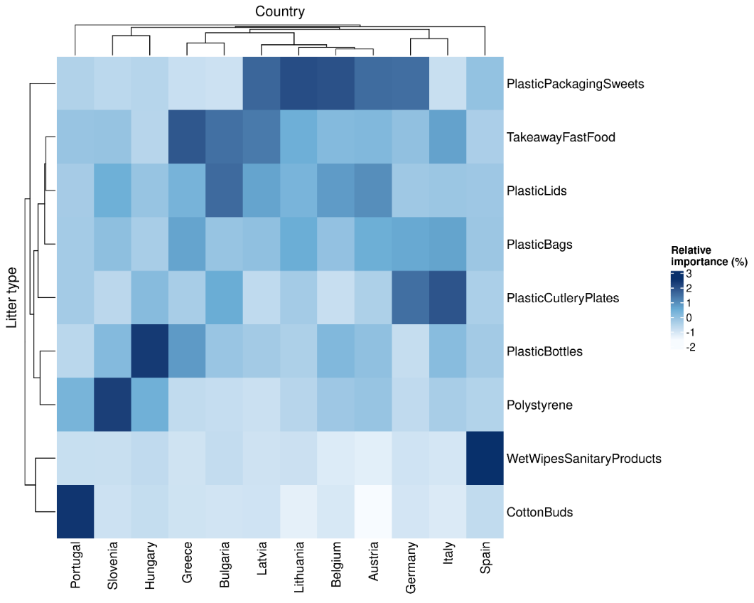
Fig. 10. Heatmap showing the standardised relative representation of the subset of litter categories classified as single-use plastics (SUP) across the 12 participating countries, observed between 2021 -2024, with hierarchical clustering applied to both countries (columns) and SUP litter categories (rows). Z-score scaling highlights how the relative representation of each SUP litter category varies between countries. The dendrograms group countries with similar litter-category profiles and SUP litter categories with similar patterns across countries.

Restricting the analysis to SUP categories affected the observed similarity patterns in litter composition among countries (Fig. 10). Compared to the full litter dataset, the SUP subset showed a more distinct clustering of countries in neighbouring geographical areas, such as Hungary and Slovenia, Greece and Bulgaria, and Lithuania and Latvia, indicating similar litter composition profiles. Some clusters also included non-neighbouring countries however, such as Belgium and Austria, and Germany and Italy. ‘WetWipesSanitaryProducts’ and ‘CottonBuds’ formed a distinct cluster in the litter category dendrogram, reflecting their particularly high representation in Spain and Portugal, respectively.

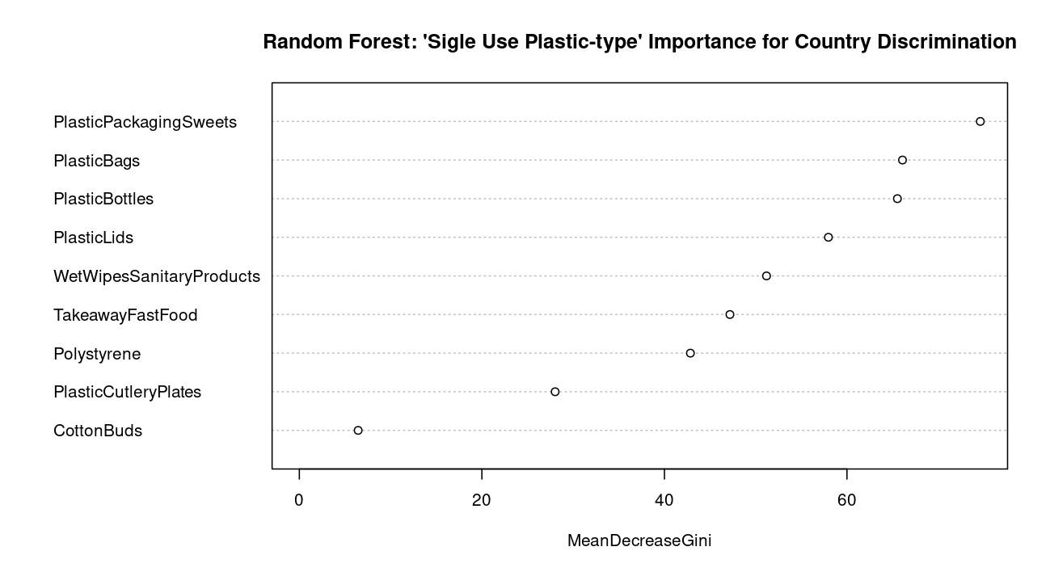
Fig. 11. Variable importance of the subset of litter categories classified as single-use plastics (SUP), observed between 2021 -2024, for discriminating among countries based on the multivariate random forest classification model, expressed as mean decrease in Gini index (MDG). Higher values indicate a greater contribution of a litter category to country classification, with the litter categories ‘MetalBeverageCans’ and ‘PlasticPackagingSweets’ showing the highest discriminatory importance.

Single-use plastic litter composition also differed significantly among countries (PERMANOVA; adonis2, 999 permutations; F = 5.26, R² = 0.097, p = 0.001) (Table 2), with treatment “country” explaining 9.7% of the variation, comparable to the overall litter analysis, leaving the majority of observed variance (90.3%) unexplained. RF classification showed even lower predictive performance for the SUP subset (OOB error = 73.3%; accuracy ≈ 27%), with widespread misclassification among countries (Supplementary Information X), indicating an even more limited discriminatory power of SUP composition. Within-country variability was comparable among countries (betadisper; F = 1.51, p = 0.126), with no significant differences in multivariate dispersion (Supplementary Information X). Despite the more distinct geographical clustering observed in the heatmap (Fig. 10), RF classification showed lower predictive performance for the SUP subset than for the overall dataset (38%), suggesting that these geographical patterns did not consistently translate into distinguishable country-level SUP profiles.

Regarding variable importance, ‘PlasticPackagingSweets’ contributed most to country discrimination, followed by ‘PlasticBags’ and ‘PlasticBottles’ (Fig. 11). ‘PlasticLids’, ‘WetWipesSanitaryProducts’, ‘TakeAwayFastFood’ and ‘Polystyrene’ showed intermediate importance, while ‘PlasticCutleryPlates’ and ‘CottonBuds’ contributed relatively little. Overall, these results suggest that, although a few SUP categories contributed to distinguishing countries, their composition provided even less discriminatory power than the full litter dataset.

Floating macrolitter

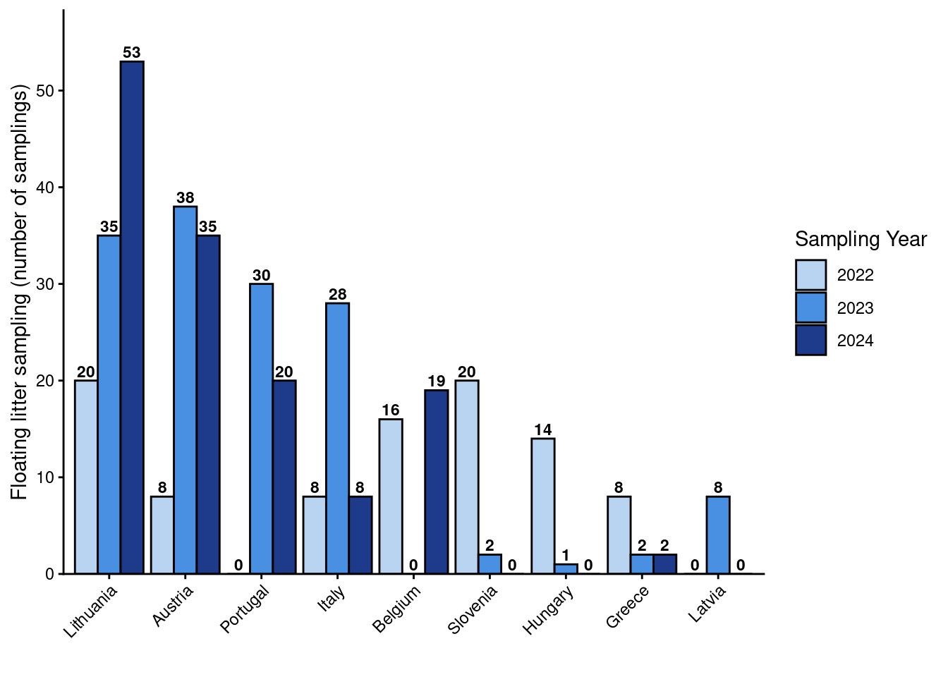
Fig. 12. Yearly number of floating litter sampling events conducted under the Plastic Pirates – Go Europe! initiative between 2022 and 2024 in Austria, Belgium, Greece, Hungary, Italy, Latvia, Lithuania, Portugal and Slovenia.

Floating litter data were collected between 2022 and 2024, with substantial sampling effort across participating countries, though the number of samples varied between years (Fig. 12). The highest number of sampling campaigns was carried out in Lithuania in 2024 (53 sampling campaigns), followed by Austria in 2023 (38 campaigns), and by Lithuania and Austria in 2023–2024 with 35 campaigns each, respectively.

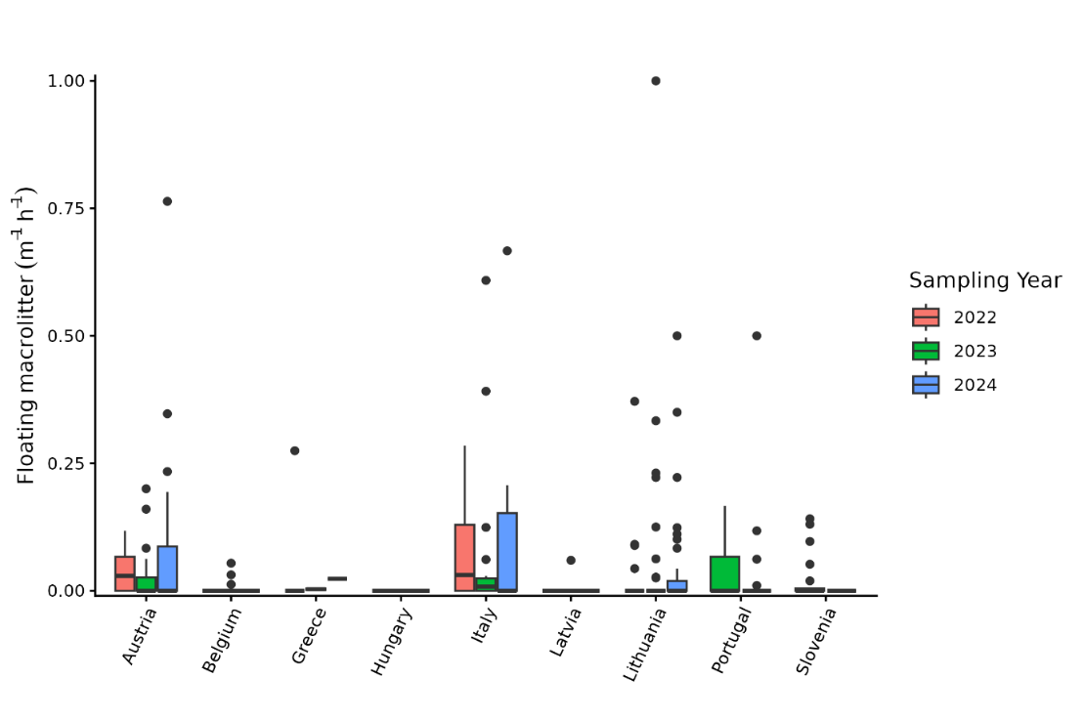
Fig. 13. Floating macrolitter abundance (items m⁻¹ h⁻¹) recorded through visual observations across the observable river width over defined periods of time during 2022–2024 in each participating country.

Floating macrolitter, which was counted visually within the observable river width over a defined period, was generally scarce across all countries and years, with median values close to zero in most cases (Fig. 13). The distribution was strongly skewed, characterised by numerous low observations and occasional high values, indicating that floating macrolitter was typically scarce but subject to sporadic high-density events. The highest density was recorded in Lithuania in 2023 (≈ 1.0 items m⁻¹ h⁻¹), followed by Austria in 2024 (≈ 0.75 items m⁻¹ h⁻¹) and Italy in 2024 (≈ 0.65 items m⁻¹ h⁻¹). These countries also exhibited a wider range of values and multiple outliers compared to others. In contrast, Belgium, Greece, Hungary, and Latvia consistently showed low floating macrolitter densities (< X items m⁻¹ h⁻¹) with minimal variation, indicating rather low and stable levels, while Portugal and Slovenia displayed slightly greater variability and levels.

Discussion
European Macrolitter signature and Spatial Heterogeneity
The results reveal three complementary aspects of European riverbank macrolitter composition: broad compositional overlap across countries, distinct regional and local patterns, and substantial variation (> 90%) that cannot be explained by national identity alone. Surface-floating macrolitter was generally scarce across countries and years, with median values near zero, but showed a strongly skewed distribution with occasional peaks of up to ~1.0 items m⁻¹ h⁻¹, suggesting sporadic high-density transport events. Although PERMANOVA detected statistically significant differences among countries for the riverbank macrolitter (p = 0.001), country identity explained less than 10% of the total variation in both the full macrolitter dataset (R² = 0.098) and the SUP subset (R² = 0.097). This limited explanatory power was also reflected in the RF classification, which achieved relatively low overall accuracies of approximately 38% and 27% for the full dataset and SUP subset, respectively. Together, these results indicate compositional overlap between countries, despite statistically detectable differences.

Z-score hierarchical clustering heatmaps further illustrated this overlap, showing similarities in the representation of frequently observed items, such as cigarette butts, plastic lids, takeaway packaging and general plastic fragments, alongside geographical groupings among neighbouring countries, particularly Hungary and Slovenia, Bulgaria and Greece, and Lithuania and Latvia (SUP). Random forest variable importance identified plastic packaging for sweets, plastic bags and plastic bottles as the main contributors to country discrimination within the SUP subset, although their widespread occurrence across countries limited their overall discriminatory power. Despite these broad similarities, distinct geographical patterns were also apparent. The Iberian Peninsula displayed a particularly distinct SUP profile, with wet wipes and sanitary products prominent in Spain, and cotton buds and polystyrene relatively more represented in Portugal. Single-use plastic items such as food packaging, plastic bags, plastic bottles, and takeaway products were prominent across several Central and Eastern European countries.

The broad compositional overlap observed across countries may partly reflect similarities in consumption patterns, the widespread availability of standardised consumer products and packaging, and increasingly integrated European markets. Many frequently observed litter items originate from mass-produced and widely distributed products, potentially resulting in comparable litter inputs across countries (González-Fernández & Hanke, 2018; Morales-Caselles et al., 2021). In particular, the widespread presence of SUP items and cigarette butts may reflect standardised consumption habits, globalised packaging practices and common product availability across integrated European markets (Kiessling et al., 2019, 2023; van Emmerik et al., 2020; Dittmann et al., 2024; Philip et al., 2024). Despite these broad similarities, variation between geographical regions and individual sampling locations highlights the heterogeneous nature of riverbank litter composition. These patterns suggest that, alongside widespread market-related influences, regional and local circumstances also contribute to shaping the types of litter observed along European riverbanks.

Several anthropogenic factors may contribute to this heterogeneity, including population density, surrounding land use, proximity to urban and industrial areas, recreational activities, local consumption habits and waste-management practices (REF). Differences in surrounding infrastructure and human activities may influence both the types and quantities of litter entering nearby waterways. Furthermore, the relatively low proportion of variation explained by country identity indicates that substantial variability remains unexplained at the national level, potentially reflecting differences among individual rivers and sampling locations, as well as other factors not captured by the present study.

Beyond differences in litter inputs, the transport, retention and accumulation of litter along riverbanks is also influenced by an interplay between river characteristics, hydrological conditions, climate and weather patterns, and the physical properties of individual litter items, such as their size, shape and buoyancy (REFs). Riverine litter is subject to various hydrological processes, including runoff, downstream transport, retention along riverbanks and remobilisation during high-flow events. This mechanism aligns directly with our floating macrolitter observations: because litter is temporarily trapped and stored along riverbanks and riparian vegetation, floating transport does not occur as a continuous or homogeneous stream, but rather as sporadic pulses when items become remobilised during specific weather or high-discharge events. These processes influence where litter accumulates and how it is redistributed throughout river systems, with their relative importance depending on litter characteristics and local environmental conditions (González-Fernández et al., 2021; Kiessling et al., 2023). For example, high litter densities have been reported at national borders and downstream tidal accumulation zones in the Rhine-Meuse delta, illustrating how rivers can function both as pathways for transboundary litter transport and as long-term retention zones (Van Emmerik et al., 2020). However, hydrological regimes and river characteristics vary considerably across Europe. Differences in river size, river morphology, seasonal flooding, snowmelt, periods of low flow and seasonal drying may therefore contribute to differences in litter transport and accumulation between rivers and regions (REFs). Consequently, the litter composition observed along riverbanks may reflect not only local litter inputs but also the environmental conditions and transport processes influencing its subsequent distribution and retention.

Overall, European riverbank macrolitter composition appears to be shaped by both widespread consumption-related influences and geographically variable environmental and anthropogenic factors. While recurring litter categories point towards broad compositional similarities across countries, regional patterns and substantial unexplained variation indicate that national-level comparisons alone cannot fully capture the complexity of litter distribution. This highlights the value of harmonised, large-scale monitoring approaches, which allow shared patterns across countries to be identified while also capturing geographical heterogeneity and variation at regional and local scales.

The alignment between our pan-European findings and previous single-nation assessments demonstrates that national-level surveys were recovering localised expressions of a broader, continent-wide litter signature. Earlier national baselines established through the Plastic Pirates framework in Germany recorded median riverbank litter densities ranging between 0.14 items/m² and 0.28 items/m² across a seven-year period (2016-2022), with plastics and cigarette butts consistently constituting the primary litter fractions, suggesting that mass-produced consumer items constitute a recurring baseline input across river systems ((Kiessling et al., 2019; Dittmann et al., 2023 & 2024). Similar compositional patterns have been observed across other European rivers using distinct citizen-science and expert protocols. For instance, nationwide surveys along French riverbanks (Plastique à la loupe) identified plastics as the dominant material (55.1%), with SUP items, particularly food-related packaging, caps, and drink containers, accounting for 43.4% of all macrolitter (Philip et al., 2024). Likewise, assessments in the Dutch Rhine-Meuse delta reported an even higher plastic fraction (85.1%), heavily dominated by unidentified plastic pieces, expanded polystyrene (EPS) fragments, food wrappers, caps, plastic bottles, and cotton swabs (Van Emmerik et al., 2020).

By demonstrating that these independently conducted national surveys converge on the exact same core categories, specifically SUP packaging, cigarette butts, and plastic fragments, our results confirm that these items represent a persistent, structural feature of European riverbanks rather than highly localised or temporary pollution events. Furthermore, this cross-study consistency highlights the robustness of standardised monitoring protocols, showing that participatory initiatives can reliably capture broad environmental baselines that transcend individual rivers and national boundaries (Philip et al., 2024).

Policy Implications - Evaluating EU & National Plastic Regulations
The findings have important implications for European plastic pollution policy. The occurrence of similar major litter categories across the countries investigated, despite country identity explaining less than 10% of the total compositional variance, highlights the relevance of coordinated EU-wide measures targeting widely distributed consumer products, alongside national and local interventions (Kiessling et al., 2023).

The prevalence of litter categories targeted by the SUPD (Directive (EU) 2019/904) indicates that the Directive addresses several of the primary litter sources identified in this study. However, the prominence of packaging-related items, such as sweet wrappers, plastic bags, plastic bottles, and takeaway packaging, highlights the limitations of product restrictions alone, which scenario modelling shows yield only marginal overall litter reductions (2–6%; Kiessling et al., 2023). Achieving substantial environmental reductions requires the full combination of policy instruments alongside the newly adopted PPWR (Kiessling et al., 2023). Beyond Extended Producer Responsibility (EPR), which shifts waste management and cleanup costs onto producers to incentivize eco-design, this includes product design requirements (e.g., tethered caps on beverage bottles to prevent separate discards), mandatory Deposit Return Schemes (DRS), labelling requirements (informing consumers of plastic content, proper disposal, and environmental harm for items like cigarette filters or plastic bags), and targeted consumer awareness campaigns promoting reusable alternatives (Kiessling et al., 2023). Combining these upstream product standards with downstream behavioral measures is essential to regulate widespread SUP inputs across European river catchments.

The substantial unexplained variance (> 90%) and distinct geographical clusters, such as the high relative representation of wet wipes in Spain and cotton buds in Portugal, also demonstrate that EU-wide product policy cannot serve as a stand-alone solution. These localised hygiene signatures may partly reflect the influence of urban drainage systems/infrastructure gaps, including stormwater runoff and combined sewer overflows during heavy rainfall events (Devriese et al., 2025; van Leeuwen et al., 2023). Mitigating these inputs requires multi-level governance, where EU-level market restrictions are integrated with regional waste-management practices and urban water infrastructure under the recast Urban Wastewater Treatment Directive (UWWTD) and Water Framework Directive (WFD).

Finally, the environmental response to recent legislative interventions may experience a significant time lag. The continued detection of items already restricted or banned under the SUPD, such as plastic cotton buds, illustrates the role of legacy litter. River systems function not only as transport pathways but also as long-term retention reservoirs, trapping litter in bank vegetation, sediments, and hydraulic structures until remobilised by high-flow events (van Emmerik et al., 2020, 2023; Dittmann et al., 2024). Evidence from long-term monitoring supports this interpretation. Long-term monitoring across German river basins (2016–2022) revealed no significant decline in litter density despite the introduction of new plastic-related legislation, most likely reflecting the persistence and remobilisation of legacy litter (Dittmann et al., 2024; Dittmann et al., 2025). Consequently, a delay is expected between upstream policy implementation and measurable reductions in riverbank litter. This persistence underscores the necessity of sustained, harmonised monitoring approaches, such as Plastic Pirates – Go Europe!, which generate standardised cross-border datasets essential for distinguishing ongoing inputs from legacy remobilisation and evaluating progress toward the ZPAP target of reducing plastic litter by 50% by 2030 (Devriese et al., 2025).

These monitoring efforts are also relevant beyond freshwater management, as rivers represent an important pathway through which land-based litter reaches coastal and marine environments. Reducing riverine litter therefore contributes to broader EU marine environmental objectives and supports the implementation of the Marine Strategy Framework Directive (MSFD; Directive 2008/56/EC), which aims to achieve Good Environmental Status (GES) in European seas, including under Descriptor 10 (Marine Litter). Furthermore, although plastic litter is not yet explicitly included among the ecological status indicators assessed under the Water Framework Directive (WFD; Directive 2000/60/EC), its integration into freshwater monitoring frameworks could strengthen the assessment of land-based pollution and its contribution to marine litter.

Citizen Science as a Validated Tool for Policy-Relevant Monitoring
Despite historical scepticism regarding data collected by non-experts, previous comparisons with professional monitoring have demonstrated that standardised citizen-science observations from school children or crowds can produce comparable results, provided that clear and standardised protocols are used, as well as robust quality-control procedures (e.g. Van Emmerik et al., 2020; Philip et al., 2024; Zettler et al., 2017). The overlap in relative litter profiles among countries in this study also demonstrated that a common classification and sampling can provide valuable information on the categories of litter occurring across broad geographical areas. In this respect, the multi-step validation pipeline implemented by Plastic Pirates – Go Europe!, combining standardised, age-tailored sampling protocols, metadata screening, photographic verification and ATR-FTIR polymer analysis, provides an important basis for data reliability and scientific use.

By engaging large numbers of participants, such initiatives enable cost-effective monitoring across broader spatial and temporal scales than would generally not be feasible through researcher-led sampling alone. As demonstrated by this study, sustained, harmonised monitoring across Europe is essential to identify changes in litter composition and distribution, assess the effectiveness of policy measures, and to pinpoint the specific environmental and anthropogenic factors influencing plastic pollution. Beyond data collection, involving citizens directly in environmental monitoring also raises awareness and encourages more responsible behaviours, thereby connecting scientific evidence with broader societal efforts to tackle plastic pollution.

Conclusion
This study provides the first harmonised, pan-European assessment of riverine macrolitter across 13 countries through the Plastic Pirates – Go Europe! framework, delivering key insights into transboundary litter patterns, spatial heterogeneity, and transport dynamics. Our findings suggest that European riverbanks seem to share a common macrolitter baseline dominated by SUP packaging and cigarette butts, with country identity explaining less than 10% of total compositional variance. Over 90% of variability is likely driven by local site- and river-scale processes, such as surrounding land use, urban proximity, population density, and municipal waste management infrastructure, alongside distinct regional profiles, including hygiene-item clusters (e.g., wet wipes in Spain and cotton buds in Portugal) on the Iberian Peninsula and prominent SUP food packaging signatures across Central and Eastern Europe.

While the widespread occurrence of some consumer items supports harmonised EU-wide policy over fragmented national frameworks, product bans under the SUPD alone are insufficient, controlling the broader packaging footprint requires integrating EPR, eco-design, and packaging waste reduction measures under the PPWR. Furthermore, surface-floating macrolitter was generally scarce, with median densities near zero, yet exhibited a strongly skewed distribution with occasional high-density spikes, demonstrating that floating transport is episodic and non-homogeneous, driven by hydrometeorological flushing of litter temporarily retained in riverbank vegetation and sediments. Ultimately, participatory youth monitoring produces robust, policy-relevant data essential for tracking progress toward the EU ZPAZ 2030 targets, for identifying specific environmental and anthropogenic factors influencing plastic pollution, and for distinguishing ongoing plastic inputs from legacy litter remobilisation across European rivers.

Acknowledgments
First and foremost, we would like to thank all participating schoolchildren, youth groups and other volunteers across the participating countries, whose enthusiasm, curiosity and dedication made the collection of this extensive dataset possible. We are equally grateful to their teachers and supervisors for their commitment, guidance and support throughout the sampling campaigns. Their collective efforts form the foundation of the Plastic Pirates – Go Europe! project and this study would not have been possible without their contributions.

We are also grateful to all researchers and project partners who joined the campaigns in the different countries, sharing their expertise and supporting the participants throughout the sampling activities, those who contributed to data management, screening, quality control and validation, including the verification of submitted observations and polymer identification. Their combined efforts helped bridge citizen science and professional research, ensuring the quality and scientific value of the collected data.

Funding
This study was conducted within the framework of the Plastic Pirates – Go Europe! project, with financial support from various national funding bodies and project partners: XXX (Austria); XXX, SeaBioMat and VLIZ internal funds (Belgium); XXX (Bulgaria); XXX (Germany); XXX (Greece); XXX (Hungary); XXX (Italy); XXX (Latvia); XXX (Lithuania); XXX (Portugal); XXX (Slovenia); and XXX (Spain).

Data statement
Data availability: The data used in this study are publicly available in the Zenodo repository: Dhondt et al. (2025), Plastic Pirates – Go Europe!: Macrolitter data collected by citizens on riverbanks in Europe between 2022 and 2024. https://doi.org/10.5281/zenodo.15535434.

Authors’ Contributions
Order not yet determined

Choose from: conceptualisation, methodology, software, validation, formal analysis, investigation, resources, data curation, writing – original and draft, writing – review & editing, visualisation, supervision, project administration, funding acquisition
(See https://www.elsevier.com/researcher/author/policies-and-guidelines/credit-author-statement)

Nelle Meyers:
Line Debaveye:
Charlotte Dhondt:
Therese Nitschke:
Lisa Devriese:
Gert Everaert:
Jan Seys:
Ana Isabel Catarino:
Meritxell Abril:
Maria Soria:
Julio López-Doval:
Lorenzo Proia:
Patricia De La Fuente Gamero:
Antonio Canepa-Oneto:
[All contributors: Tim Kiessling, DLR Team, all participant institutions]

Conflict of interests
The authors declare that they have no known competing financial interests or personal relationships that could have appeared to influence the work reported in this paper.

References
Ecologic Institute (2020): Plastic Pirates – Go Europe!. URL: https://www.plastic-pirates.eu/en

Kassambara A, Mundt F (2020). _factoextra: Extract and Visualize the Results of Multivariate Data Analyses. doi:10.32614/CRAN.package.factoextra, R package version 1.0.7.

Kiessling, T., Knickmeier, K., Kruse, K., Brennecke, D., Nauendorf, A., Dittmann, S., Thiel, M., 2022. Plastic Pirates sampling booklet (Version English May-2022). Zenodo. [https://www.plastic-pirates.eu/en/material/download]

Liaw A, Wiener M (2002). “Classification and Regression by randomForest.” R News, 2(3), 18-22. https://CRAN.R-project.org/doc/Rnews/.

Morales-Caselles, C., Viejo, J., Martí, E., Gonz´alez-Fern´andez, D., Pragnell-Raasch, H., Gonz´alez-Gordillo, J.I., Montero, E., Arroyo, G.M., Hanke, G., Salvo, V.S., Basurko, O.C., Mallos, N., Lebreton, L., Echevarría, F., van Emmerik, T., Duarte, C. M., G´alvez, J.A., van Sebille, E., Galgani, F., García, C.M., Ross, P.S., Bartual, A., Ioakeimidis, C., Markalain, G., Isobe, A., C´ozar, A., 2021. An inshore–offshore 117 T. Kiessling et al. Waste Management 164 (2023) 106–118 sorting system revealed from global classification of ocean litter. Nat. Sustainability 4, 484–493.

Oksanen J, Simpson G, Blanchet F, Kindt R, Legendre P, Minchin P, O'Hara R, Solymos P, Stevens M, Szoecs E, Wagner H, Barbour M, Bedward M, Bolker B, Borcard D, Borman T, Carvalho G, Chirico M, De Caceres M, Durand S, Evangelista H, FitzJohn R, Friendly M, Furneaux B, Hannigan G, Hill M, Lahti L, Martino C, McGlinn D, Ouellette M, Ribeiro Cunha E, Smith T, Stier A, Ter Braak C, Weedon J (2025). vegan: Community Ecology Package. doi:10.32614/CRAN.package.vegan, R package version 2.7-2.

R Core Team (2026). _R: A Language and Environment for Statistical Computing_. R Foundation for Statistical Computing, Vienna, Austria. <https://www.R-project.org/>.

Zettler, E.R., Takada, H., Monteleone, B., Mallos, N., Eriksen, M., Amaral-Zettler, L.A., 2017. Incorporating citizen science to study plastics in the environment. Anal. Methods 9, 1392–1403.

Supplementary information
- Code
- Extra information

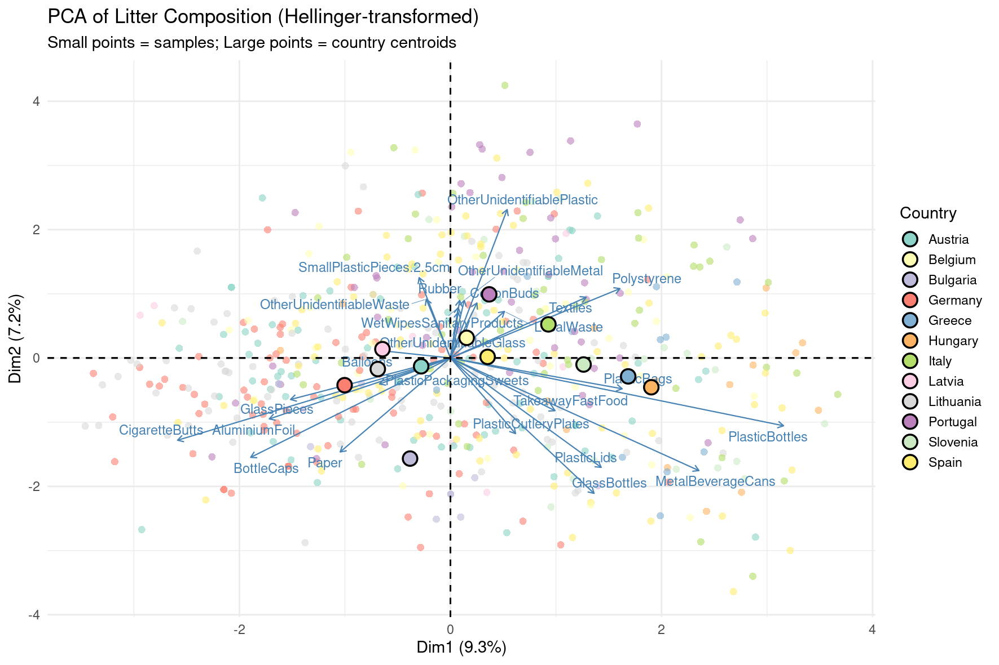
Not easy to collapse in 2 dimensions. All dimensions collapsed into 2 here, 9.3% and 7.2% (less than 30%) of the variability is explained. Is significant. Average value for each country (the centroid), in several dimensions. e.g; Hungary & Slovenia, associated with bottles, lids, … ; Spain, Belgium, Austria: close to centre, difficult to separate them from the other countries based on litter category.
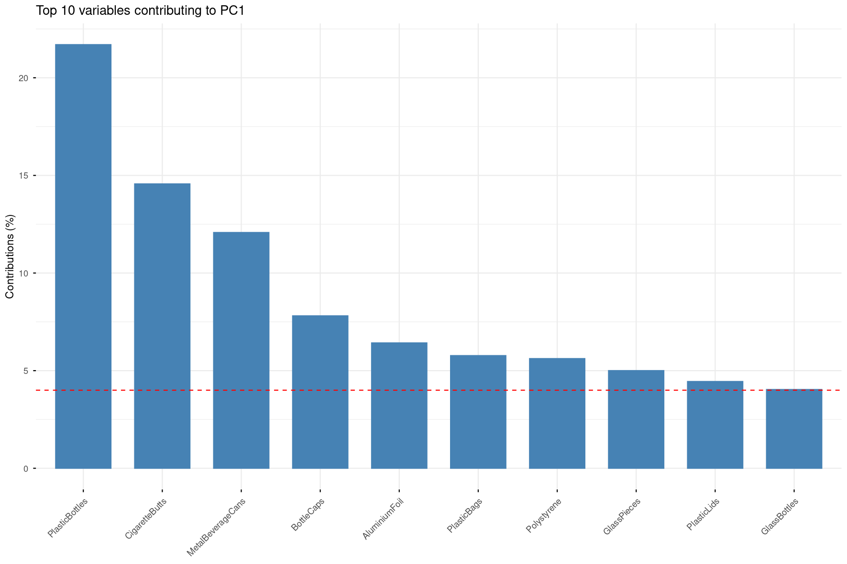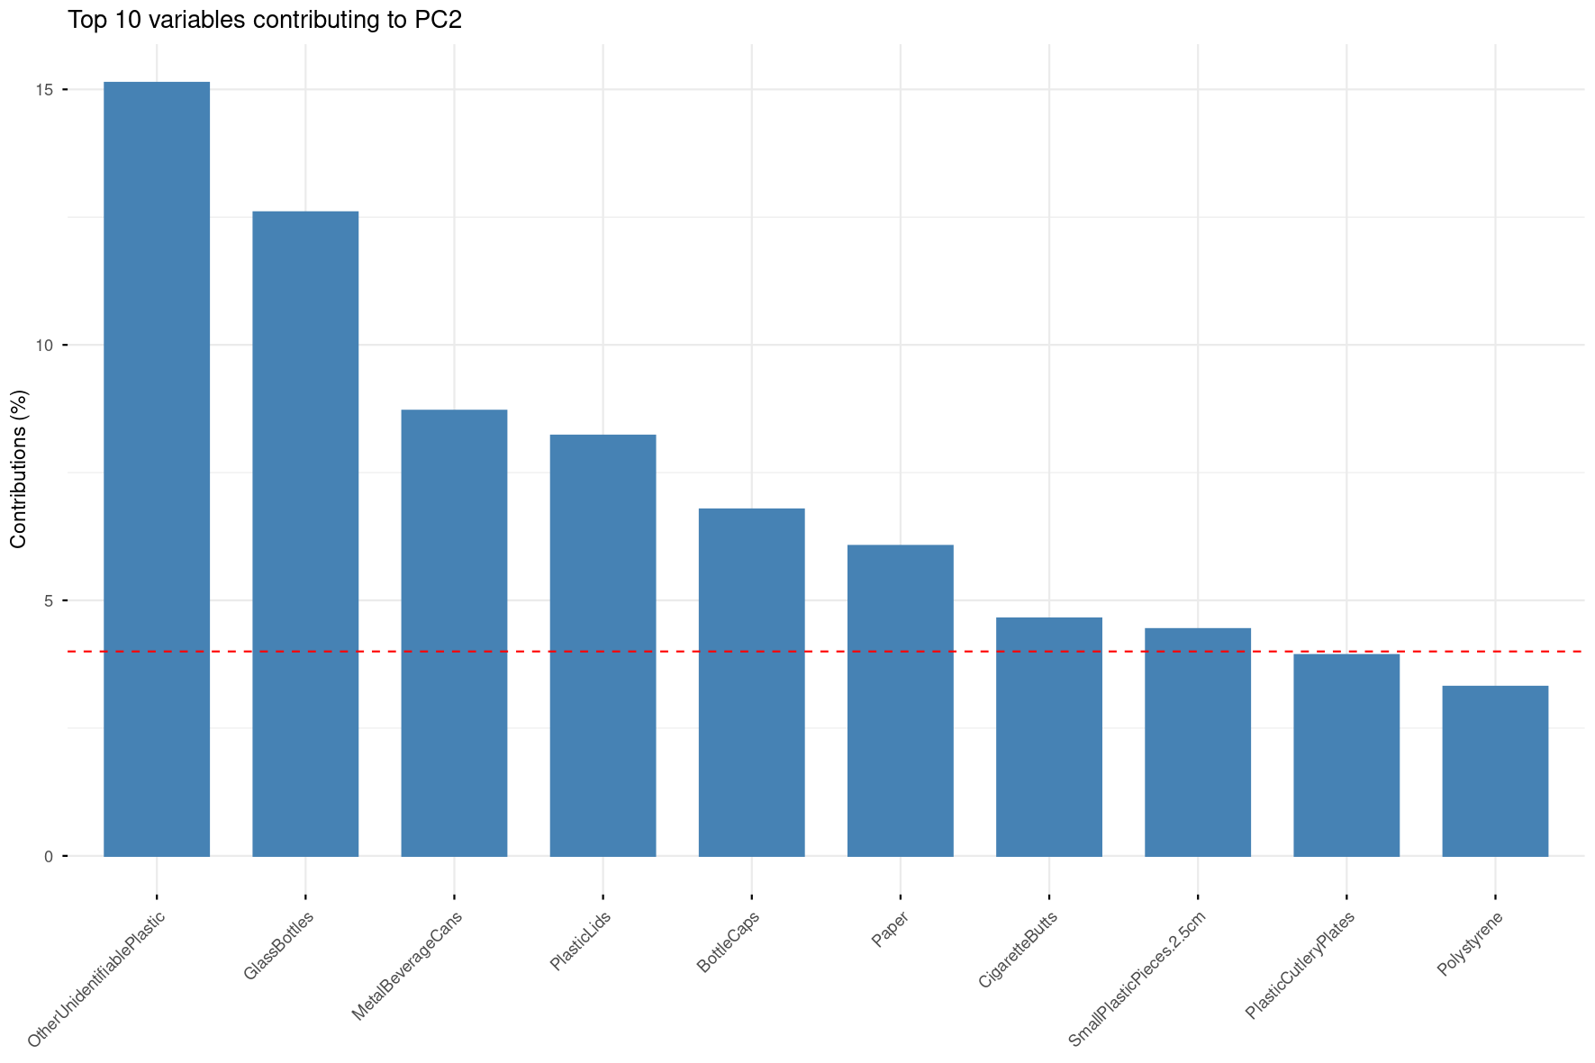
Similarity across countries can be seen through the percentage of deviation from the total European litter found. Most related countries are close each other and the higher the blue colorscale represents litter composition that is particular for each country.
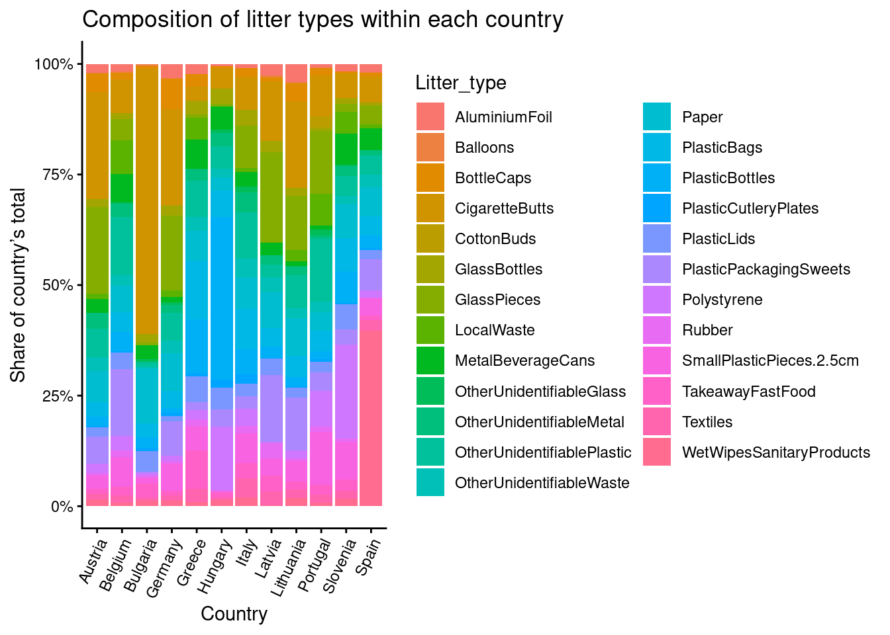

Fig. XXX
Stats to include:

SUP:
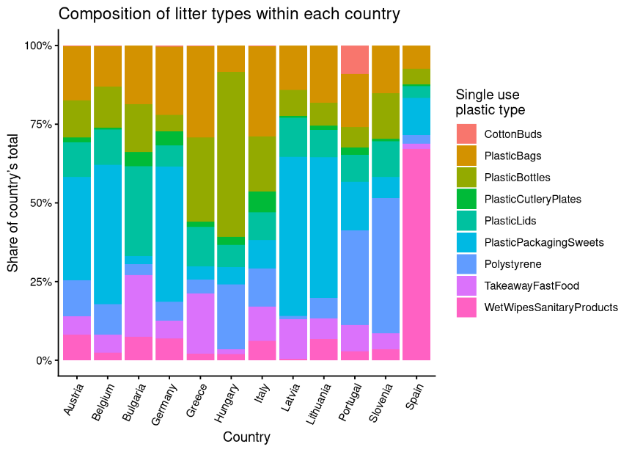

Stats:


